THE HISTORY OF PYRAMIDS
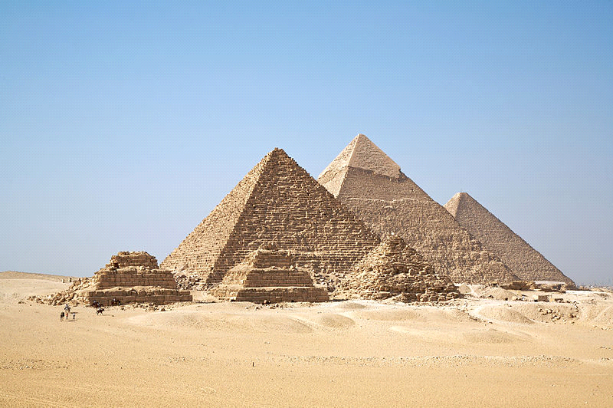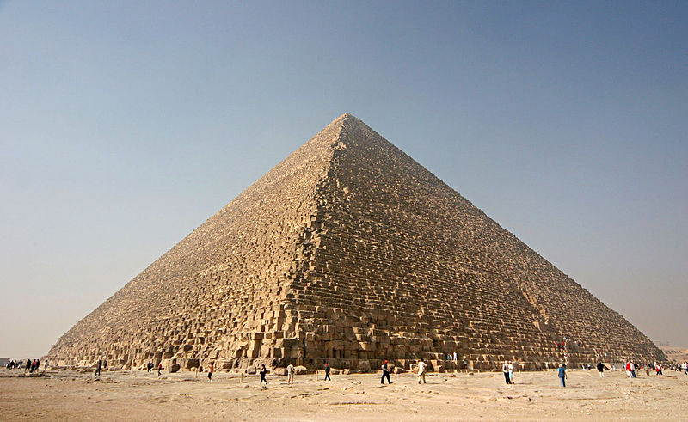
Egypt is the most known for building pyramids. They were tombs for Pharaohs and they were very big. For many years they were the largest structures in the world. Even today we can see how great they are. They were built out of bricks or stone. Egyptians believed in many gods and the most known was the god of sun named Ra. That’s why they built them in that shape and had covered with polished white limestones. The Great Pyramid of Giza is the largest in Egypt and one of the largest in the world. It’s one of the Seven Wonders of the Ancient World.The earliest known Egyptian pyramids are found at Saqqara, northwest of Memphis. The earliest among these is the Pyramid of Djoser, which was built during the third dynasty. This pyramid and its surrounding complex were designed by the architect Imhotep, and are generally considered to be the world's oldest monumental structures constructed. The estimate number of workers to build the pyramids range from a few thousand, twenty thousand, and up to 100,000.

Matija Đelekovčan , Mihael Rajkovačić i Daniel Gloc 5b

