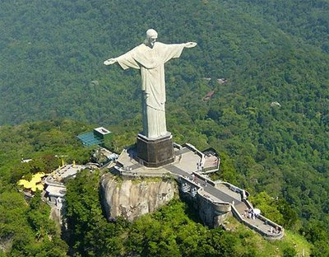
Christ the Redeemer

The statue weighs 635 metric tons, and is located at the peak of the 700-metre Corcovado mountain in the Tijuca Forest National Park overlooking the city of Rio. As a symbol of Brazilian Christianity, the statue has become an icon for Rio de Janeiro and Brazil. It is made of reinforced concrete and soapstone, and was constructed between 1922 and 1931.
The idea of building a large statue atop Corcovado was first suggested in the mid-1850s, when Vincentian priest, Pedro Maria Boss, suggested placing a Christian monument on Mount Corcovado to honour Princess Isabel, princess regent of Brazil and the daughter of Emperor Pedro II, although the project was never approve he second proposal for a landmark statue on the mountain was made in 1920. Local engineer Heitor da Silva Costa designed the statue; it was sculpted by Polish-French sculptor Paul Landowski.
The statue was struck by lightning during a violent thunderstorm on February 10, 2008, and suffered some damage to the fingers, head and eyebrows. A restoration effort was put in place by the Rio de Janeiro state government to replace some of the outer soapstone layers and repair the lightning rods installed on the statue. It was damaged by lightning again, on January 17, 2014, where a finger on the right hand was dislodged. This allows Catholics to hold baptisms and weddings there.

